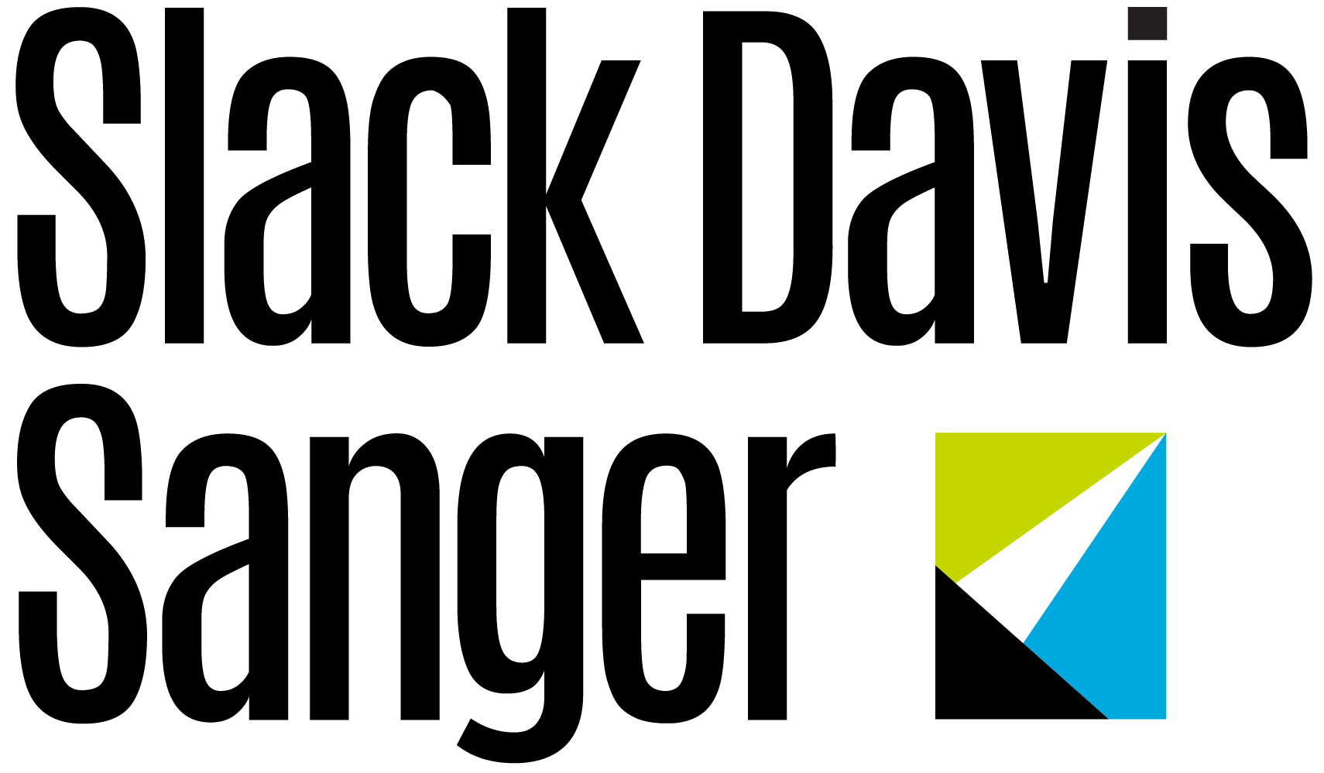
Media Contact
Aly Crea
Berbay Marketing & PR
aly@berbay.com
626.664.9115

FOR IMMEDIATE RELEASE

Slack Davis Sanger Elevates John R. Davis To Partner; Youngest Partner in Firm’s History
Austin, Texas (May X, 2020) – Slack Davis Sanger, an international personal injury and aviation law firm, has promoted John R. Davis to Partner. Based in the Austin office, Davis leads the firm’s class action and whistleblower litigation practice areas with a particular emphasis on consumer fraud, healthcare fraud, antitrust, environmental and insurance matters. Davis is the youngest attorney to be elected Partner in the firm’s 27-year history.
“John has established himself as a formidable litigator, handling high-profile class action and whistleblower matters,” said Managing Partner Mike Slack. “His relentless pursuit of justice for our clients make him deserving of this promotion, and we’re excited to see him continue to grow the class action and whistleblower practice at the firm.”
Since joining the firm in 2016, Davis has spearheaded many notable cases, such as Grigson, et al. v. Farmers Group, Inc., where he played a leading role as court-appointed Class Counsel representing with co-counsel almost 800,000 auto insurance policyholders who were allegedly discriminated against by the company. The Court recently granted preliminary approval for a $52 million settlement for the class, one of the largest settlements of its kind for a single state and one based on a novel theory of liability. Additionally, in February, he obtained a $11.85 million False Claims Act settlement against pharmaceutical marketing company, Sanofi-Aventis U.S., LLC. The whistleblower lawsuit filed by Davis and co-counsel alleged that Sanofi was funneling kickbacks to patients disguised as donations to 501(c)(3) charitable organizations.
“I am thrilled to be promoted to partner after only four years with the firm,” said John Davis. “My area of expertise coupled with the firm’s outstanding reputation and track record has provided me an incredible opportunity to grow the class action and whistleblower practice. I am grateful for the opportunity and look forward to contributing to the firm’s continued success.”
In another high-profile matter, Davis serves on the Plaintiffs’ Executive Committee in In re: Valsartan, Losartan, and Irbesartan Products Liability Litigation, MDL No. 2875 (D.N.J.) that began in 2018. The pharmaceutical recalls that triggered the litigation are the largest in U.S. history, and the litigation has shed light on shortcomings in generic pharmaceuticals imported to the U.S.
Prior to joining Slack Davis Sanger, Davis focused his practice on pharmaceutical antitrust class actions, RICO class actions and environmental natural resource damages litigation at the New Orleans environmental and class action boutique law firm, Kanner & Whiteley, L.L.C. While at Kanner & Whiteley, Davis was on the trial team representing the State of New Jersey that secured a $225 million post-trial settlement against ExxonMobil related to legacy contamination at two of Standard Oil’s (Exxon’s predecessor) oldest refineries. In addition, Davis helped obtain a $42.5 million settlement on behalf of the State of Louisiana related to GlaxoSmithKline’s diabetes drug, Avandia, which was found to cause profound cardiovascular side effects.
Davis began his career as a judicial law clerk for two federal district court judges in the U.S. District Court. He earned his B.A. from Trinity College and his J.D. from Boston College Law School. He has been selected for inclusion in Super Lawyers Rising Stars for the third year in a row for his work in class action/mass torts. He is the only Austin lawyer to make the list in his practice area.
###
About Slack Davis Sanger LLP
Slack Davis Sanger LLP is a preeminent AV-rated, nationally recognized force in civil litigation. Founded in 1993, the firm represents victims of catastrophic accidents arising from airplane and helicopter crashes, truck and car accidents, oil field and construction accidents, and other catastrophic personal injury and death accidents. With offices in Austin, Dallas and Fort Worth, the firm litigates cases throughout the country in both federal and state courts. Slack Davis Sanger has recovered hundreds of millions of dollars for the clients it has represented and has significantly contributed to industry safety improvements. Follow us on Facebook and Twitter.

